MTF Research Summary
Thomas Nikolai, Eric J. Galbraith, Michael P. Rabe
Michigan State University
February 2026

Project Name: Effects of Season Long Double Rolling on Turf Health, Disease and Spring Green Up (2023-2026)

How the MTF funding will be used to support project(s): Support funding will allow researchers to evaluate turf tolerance to daily winter rolling and study early spring green up effects as well as summer season effects pertaining to disease control, greenspeed and overall turf and soil health as daily rolling continues throughout the year.

Expected Results and Methods: This trial began in late fall 2023. We wanted to test the resilience of greens height turf to daily rolling during the cold winter months and see if there were any effects carried into the spring season when green up ratings were taken. TDR and surface temperatures were recorded on sunny days in early spring when snow was not present. Daily rolling continued throughout the growing season and greenspeed ratings, disease ratings and soil samples were taken.
Data collected during 2023-2024 supports past research showing that daily rolling significantly increases greenspeed and decreases dollar spot. Although not statistically significant, we saw a general shift from rolled plots having a worse visual color in April to having a better visual color during green up in May of 2024. TDR analysis shows rolled plots holding more moisture and spring temperature readings show rolled plots being significantly colder than unrolled plots.
Project update: Data from 2025 was similar to 2024. Every rating date showed significantly faster greens when rolled compared to control. Temperatures were significantly cooler on rolled greens. Volumetric water content was significantly higher in rolled plots.
Green-up ratings in 2025 were phenomenal in terms of plot differences. Rolled plots appeared deteriorated from post-snowmelt all the way into early-April. By mid-April, rolled plots began to look better than control plots and they were consistently greener all the way into late June.
There were also benefits to disease control in rolled plots. Although not statistically significant, there were fewer dollar spots on rolled plots. All three rating dates during a brown patch outbreak in July and early August showed statistically significant decreases in percentage brown patch on rolled plots.
Plots have been double rolled daily this fall/winter when snow is not present and surface temperature readings will be taken as soon as snow cover is gone. We hope to get some good spring green up differences again this year.

Table 1. Spring Color Ratings (1-9 scale; 1=worst, 5=acceptable, 9=best) 2025
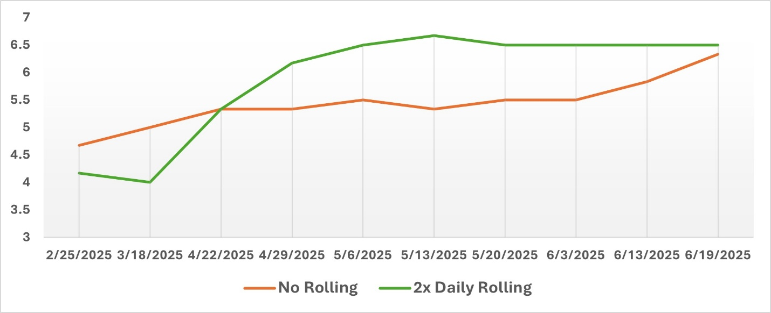
Table 2. Dollar Spot Disease Pressure (Number of Dollar Spots) 2025
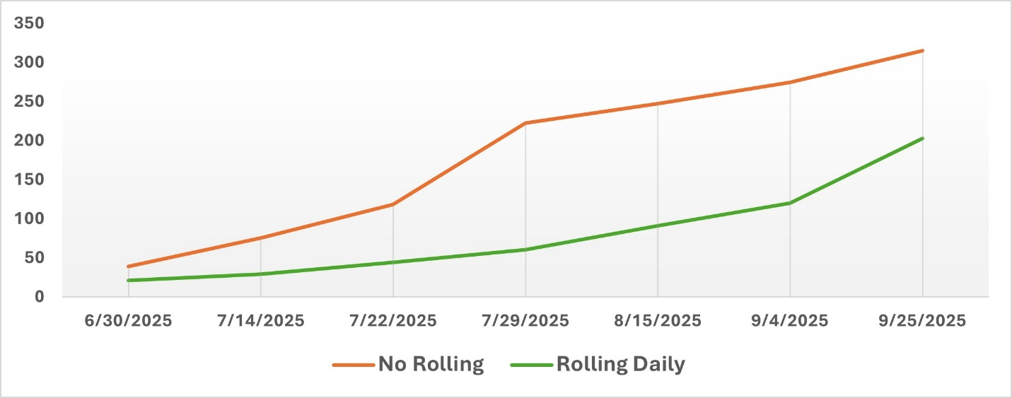

Table 3. Brown Patch Disease Pressure (Percent Plot Cover) 2025
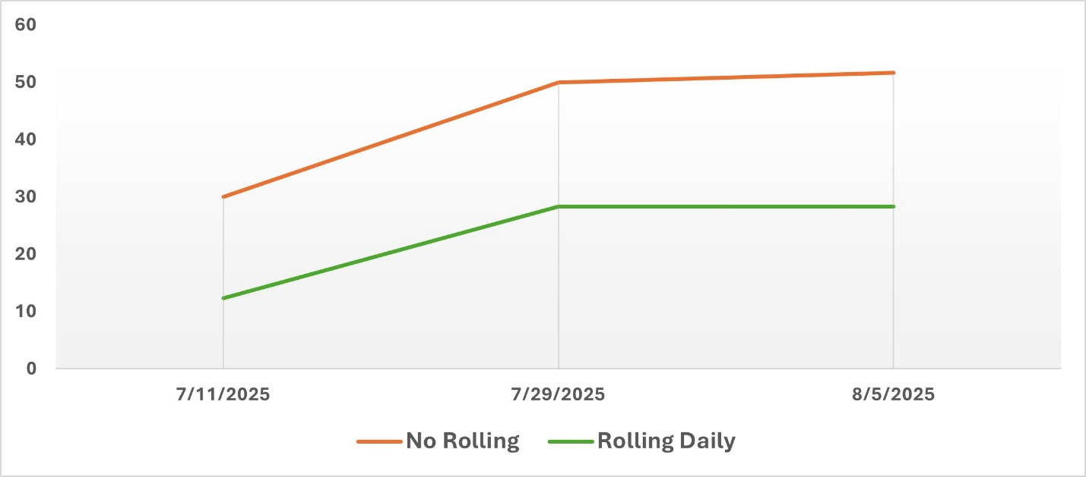

Grad Student(s) Involved: Michael Rabe

Benefit Group: This research will benefit golf courses. Rolling has become a staple practice on many golf courses, but it is not typically done in the colder months for fear of damaging the turf. Investigation into winter/early spring rolling and its effects on spring green up will prove useful to courses looking to kickstart the playing season. Benefits to disease control by rolling could add another crucial preventative tool for superintendents to use.

Figure 1. March 5, 2025
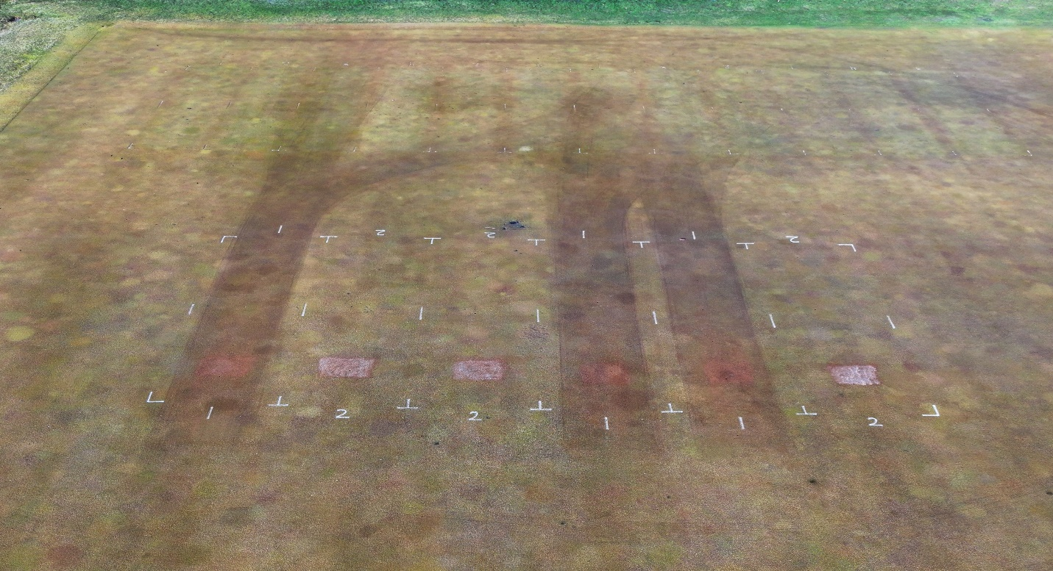
Figure 2. April 28, 2025
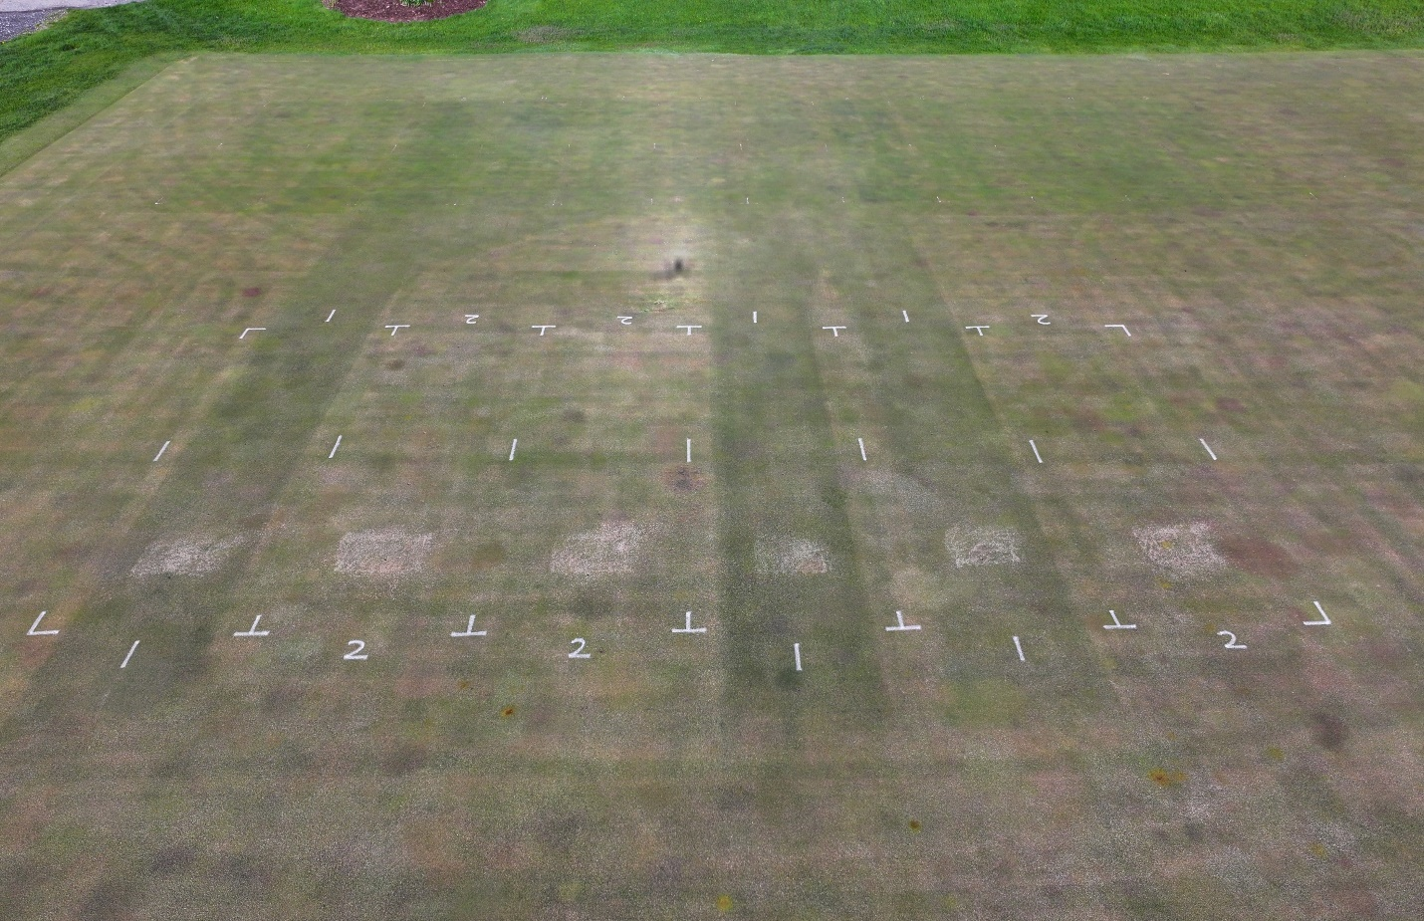
Figure 3. May 14, 2025
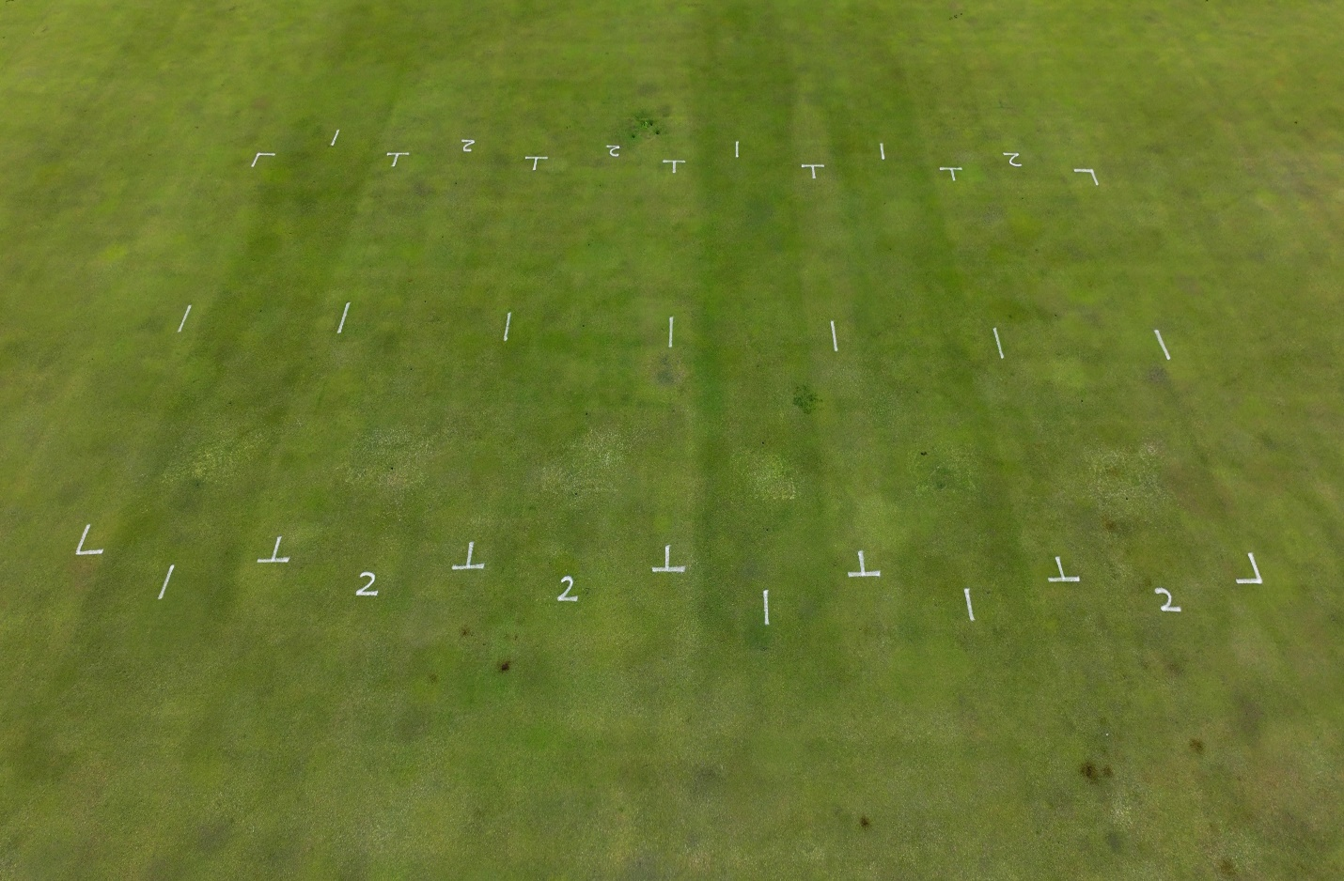

Figure 4. July 24, 2025 (dollar spot pressure)
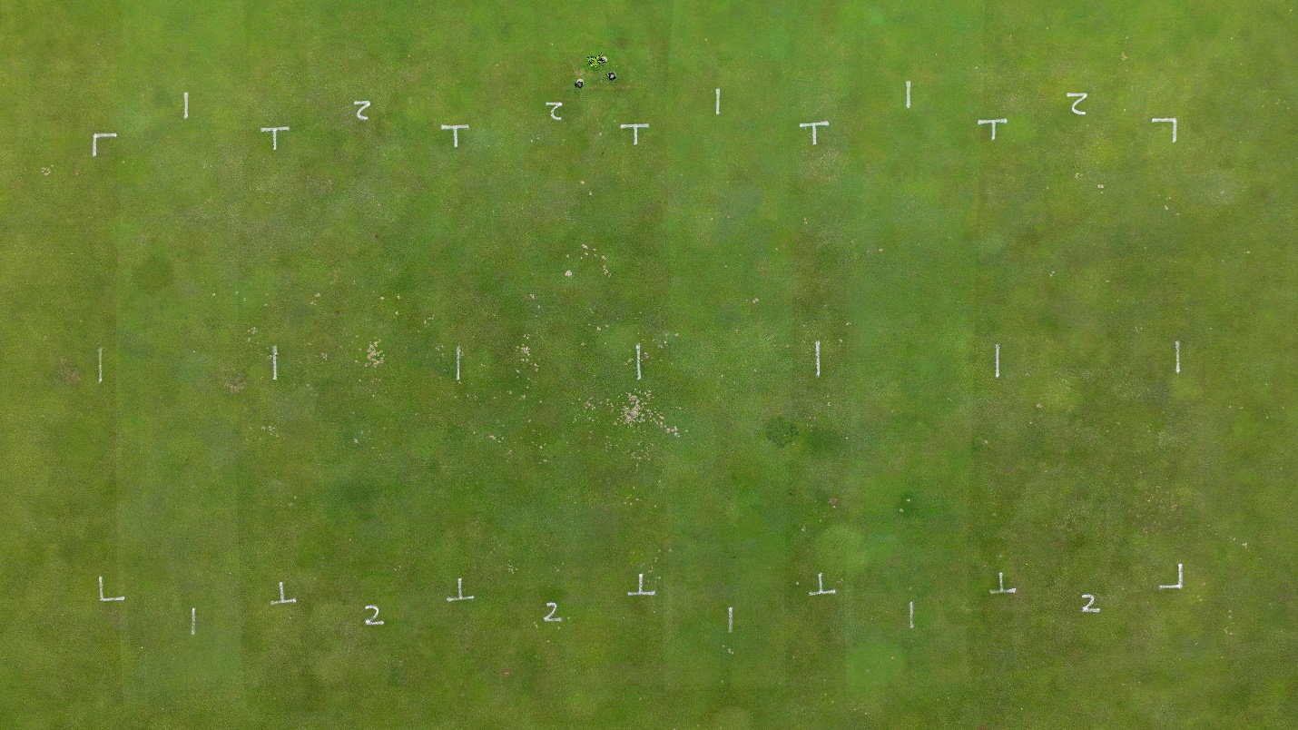
Figure 5. July 29, 2025 (brown patch pressure)
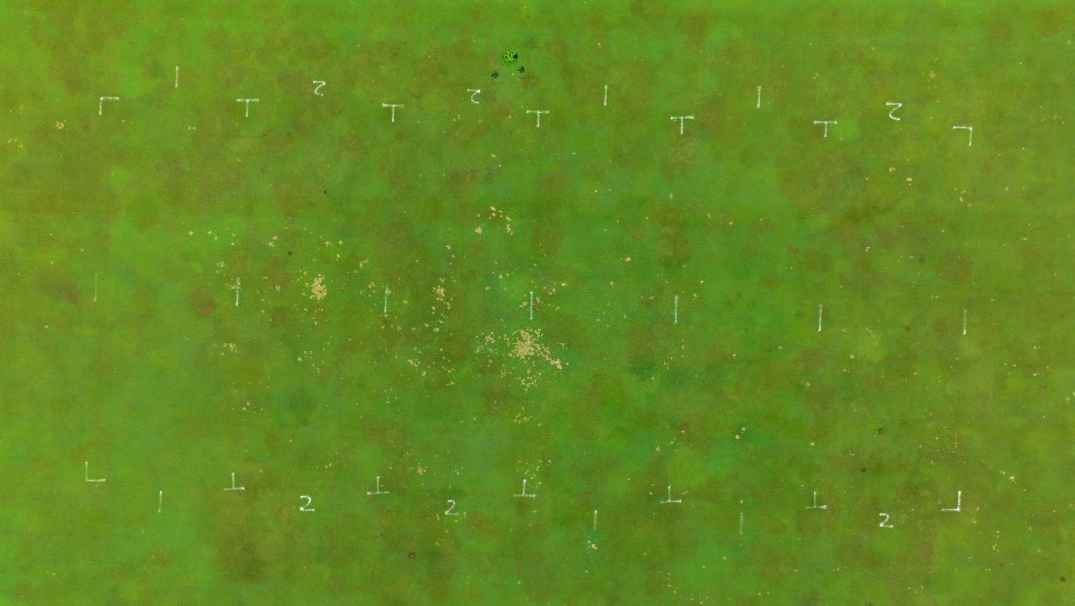

Project Duration/Future Research: This project will continue through 2026 with intent for possible future publication.

